AWS SNS: Topic Creation and Subscription Testing

Description
This walkthrough demonstrates the end-to-end workflow of the Amazon Simple Notification Service (SNS). It covers the creation of a Standard Topic named "TestMessage," the configuration of an Email Protocol subscription, and the mandatory verification process through Gmail. The sequence concludes with a successful message publication to the verified endpoint and the subsequent cleanup by unsubscribing and deleting the subscription, ensuring a complete understanding of the pub/sub (publisher/subscriber) lifecycle.
1. Initial Topic Setup
The user is on the Amazon SNS landing page. A new topic name, "TestMessage," is being entered into the "Create topic" field to initiate the setup.

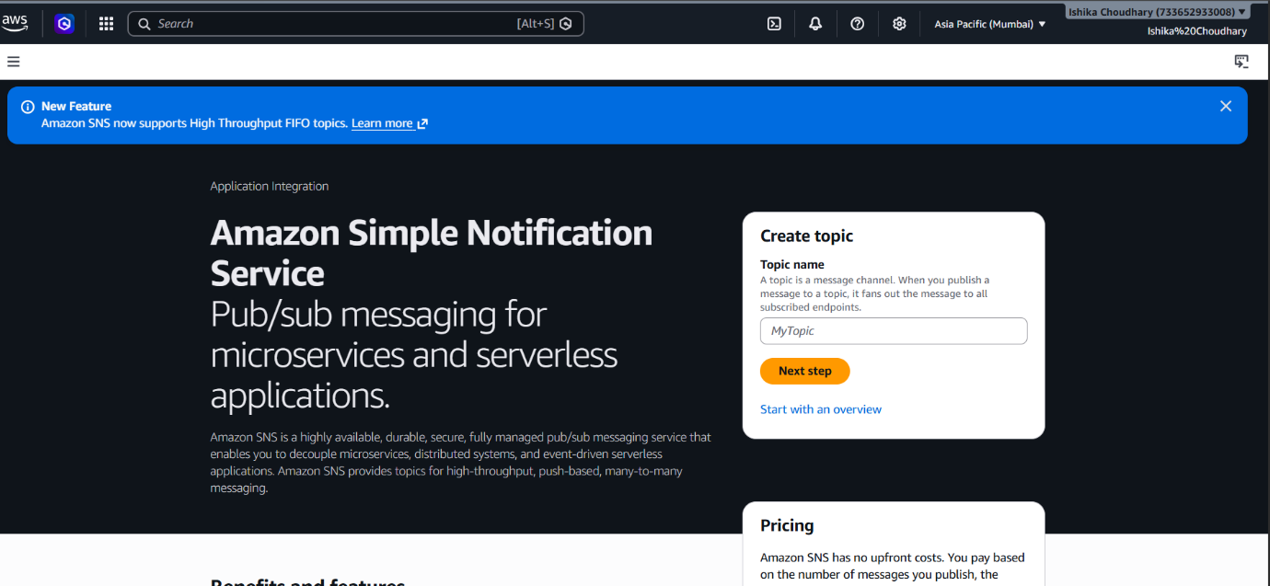

2. Topic Confirmation
The topic "TestMessage" is successfully created. The console displays the ARN (Amazon Resource Name) and confirms the type as "Standard." Currently, there are zero subscriptions.
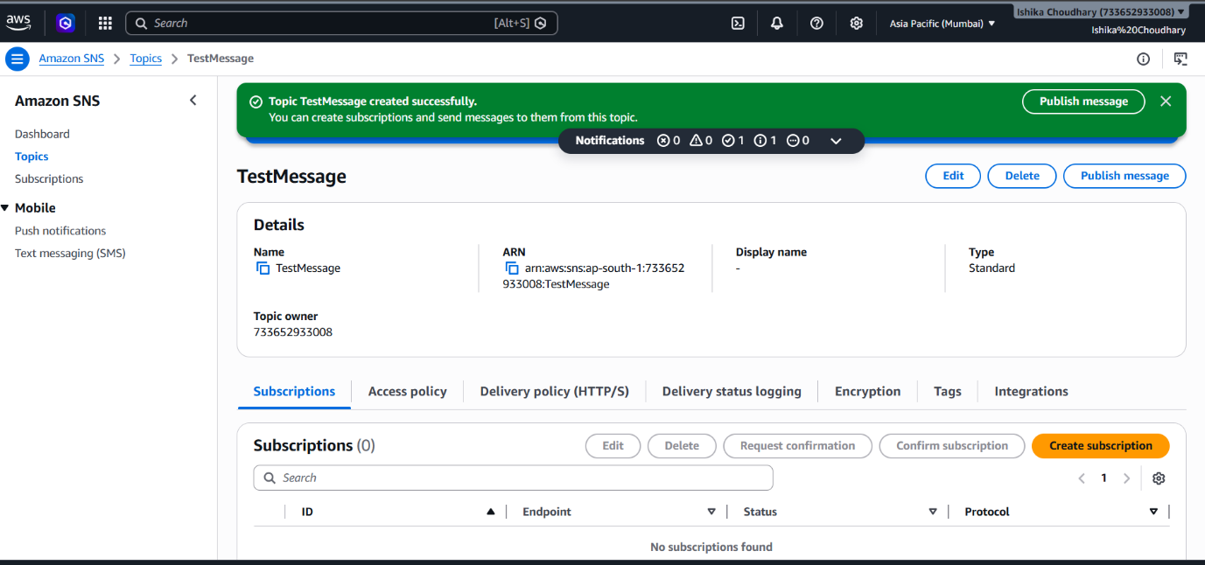

3. Creating a Subscription
The user configures a subscription for the topic. The Protocol is set to Email, and the endpoint is set to a specific Gmail address (crazyreality99@gmail.com).

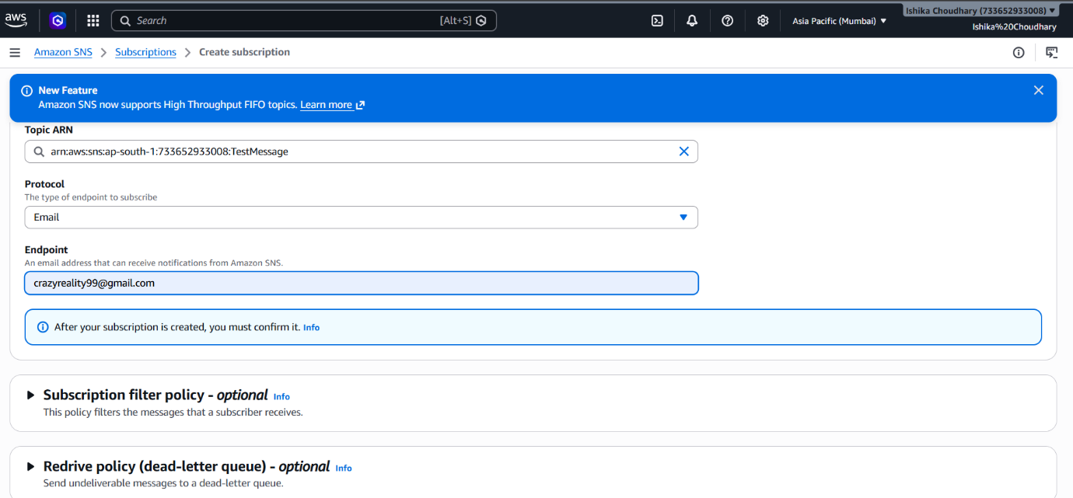

4. Subscription Pending
The subscription is created, but the status is marked as "Pending confirmation." AWS requires the owner of the email address to verify they want to receive these notifications.
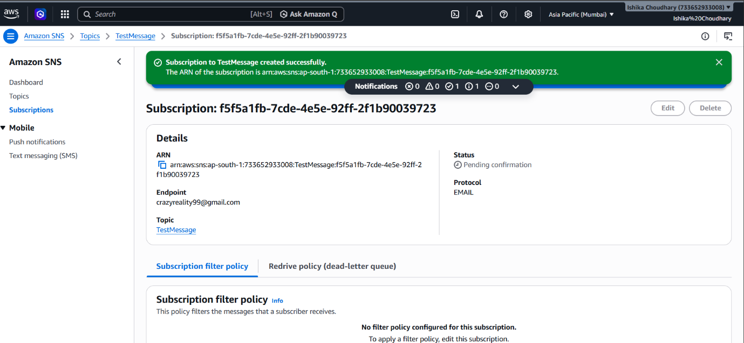

5. Email Verification
An email titled "AWS Notification - Subscription Confirmation" is received in the user's Gmail inbox. It contains a "Confirm subscription" link.

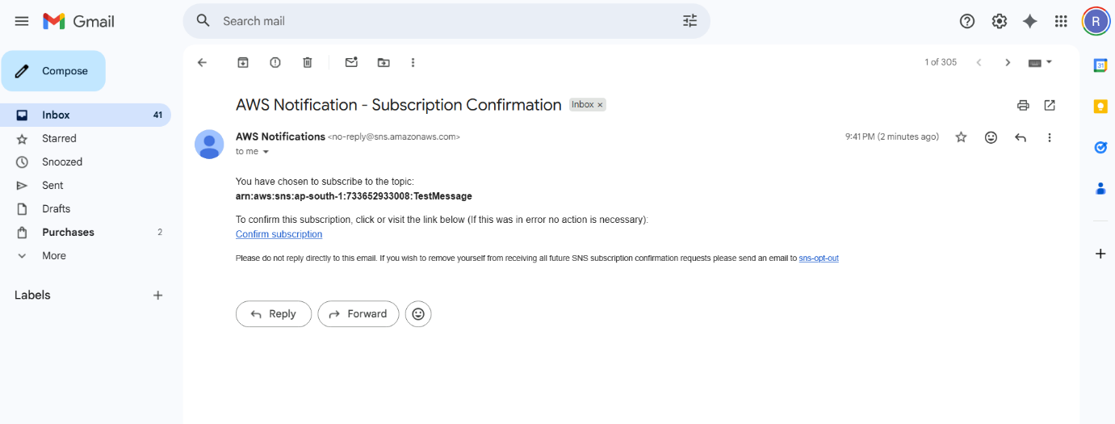

6. Confirmation Success
Upon clicking the link, a browser tab opens with an AWS confirmation message stating "Subscription confirmed!" along with the unique subscription ID.

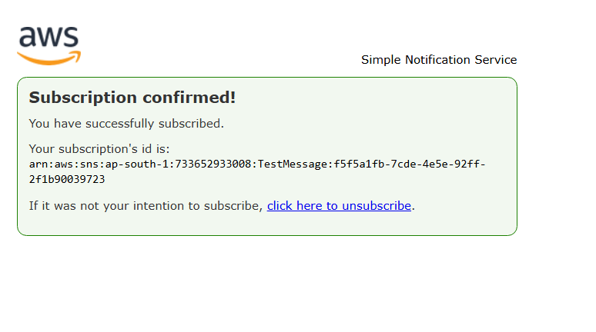

7. Verified Status
Returning to the AWS Console, the subscription status for the email endpoint has updated from "Pending" to a green checkmark labeled "Confirmed."

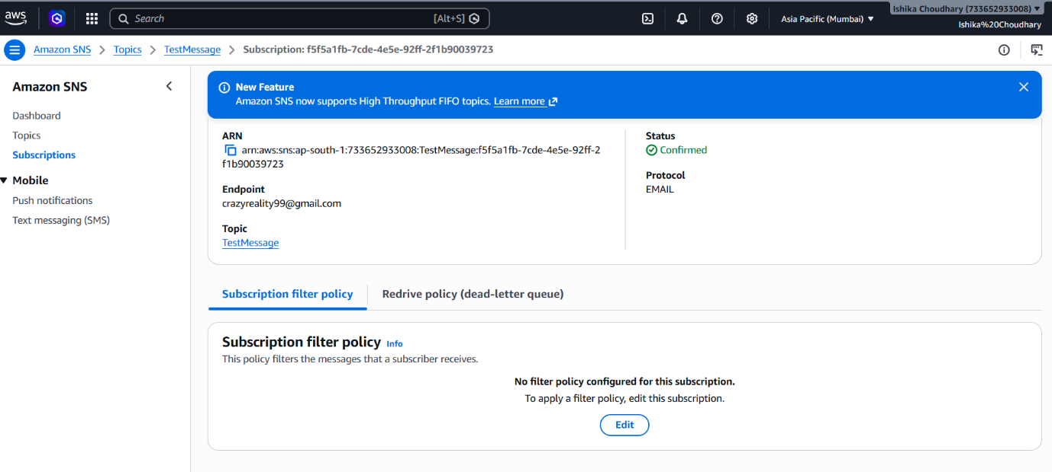

8. Publishing a Message
The user prepares to send a test notification. In the "Publish message to topic" screen, the subject is set to "Test," and the system is ready to send the message body to all confirmed subscribers.

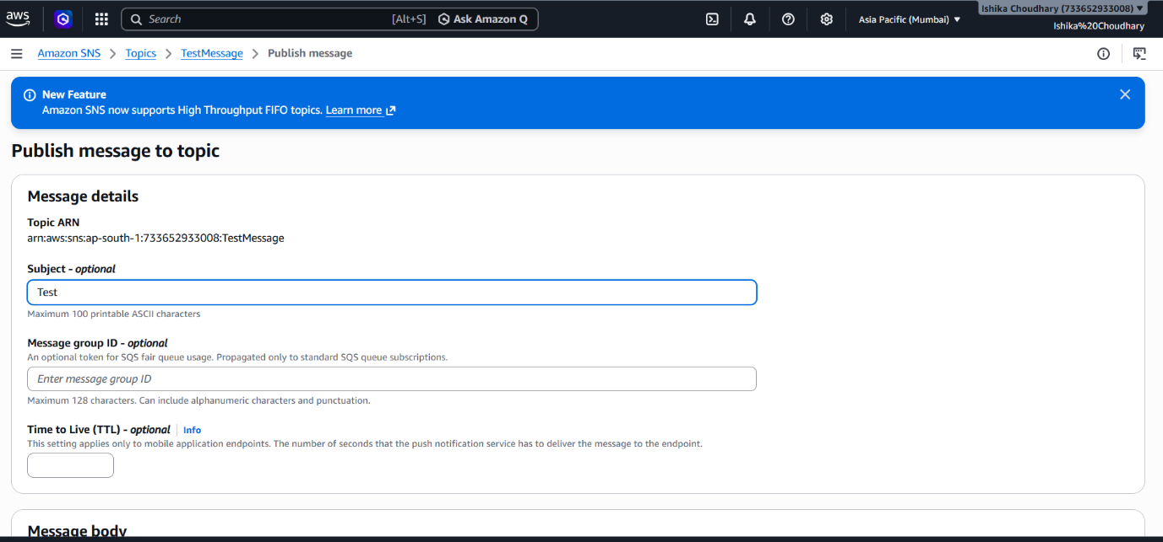

9. Entering Message Content
The user types "Test message for SNS" into the Message body field. This is the actual text that will be delivered to the subscribers.

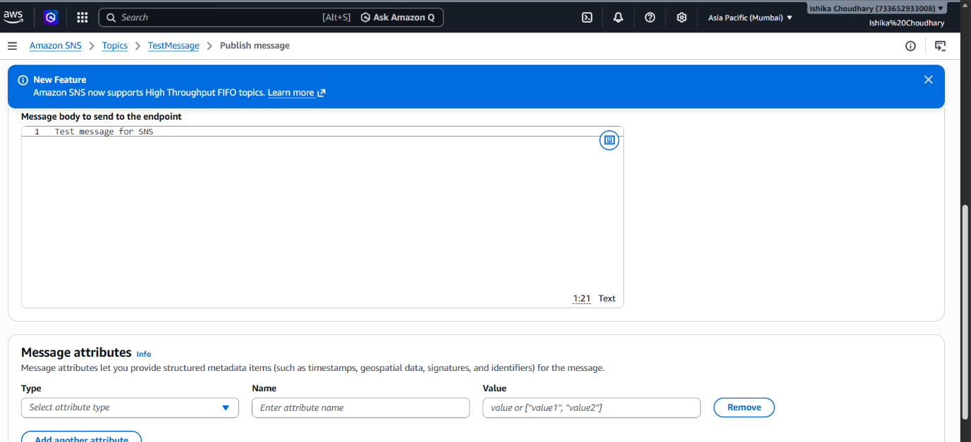

10. Successful Publication
A green banner confirms the message was published successfully. AWS provides a Message ID and Request ID as proof of the transaction within the "TestMessage" topic.

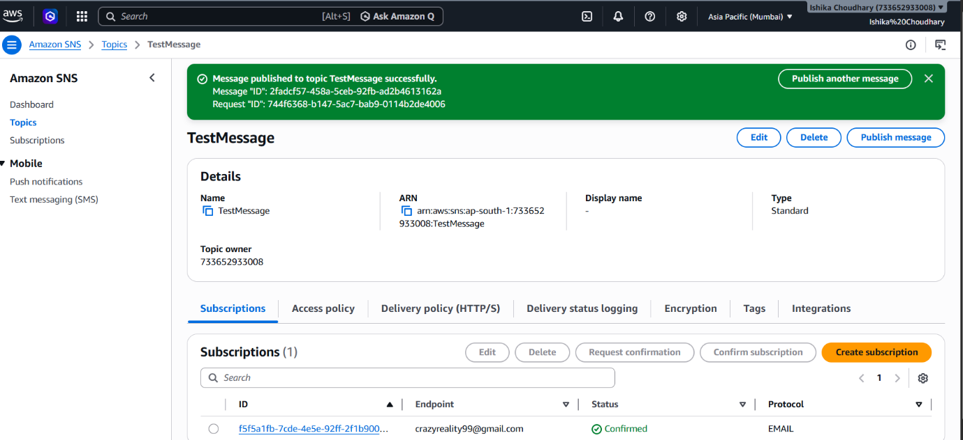

11. Notification Received
The test message arrives in the user's Gmail inbox with the subject "Test" and the body "Test message for SNS." The email also includes a mandatory link to unsubscribe from the topic.
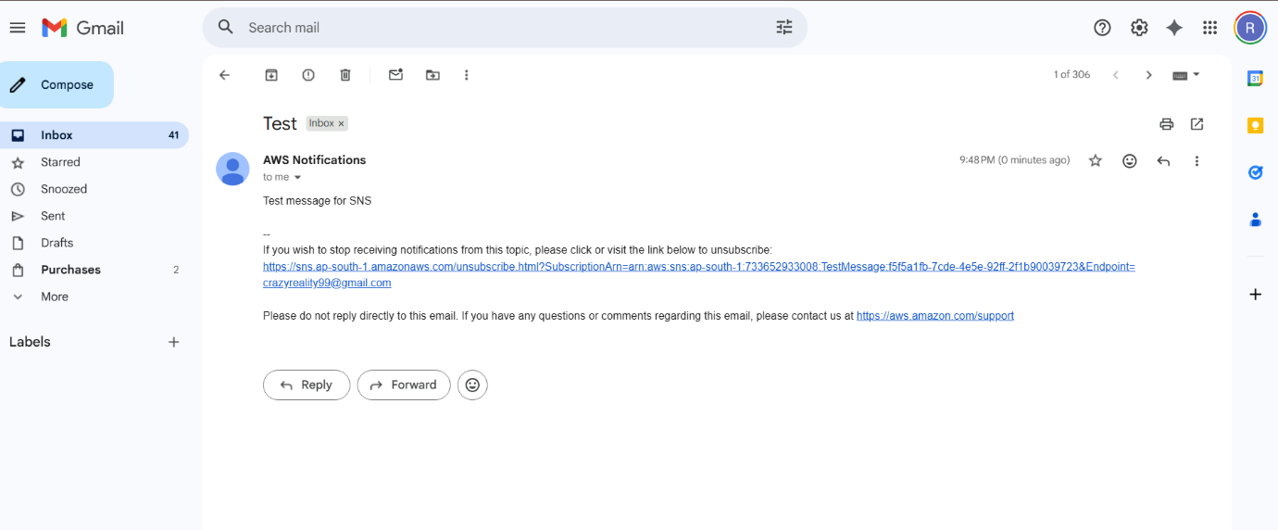

12. Unsubscribing
The user clicks the unsubscribe link in the email. A browser window opens with the confirmation message: "Subscription removed!" verifying that the specific ARN has been deleted.

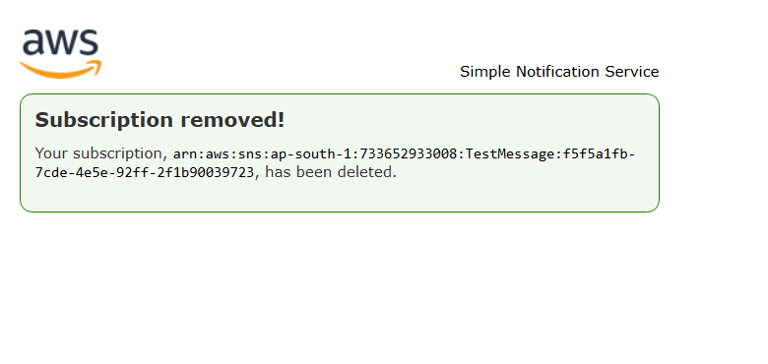

13. Final Subscription Status
Back in the AWS Console, the subscription list for the topic now shows the ID as "Deleted." While the endpoint (the email address) is still visible in the history, it is no longer an active subscriber to the "TestMessage" topic.

